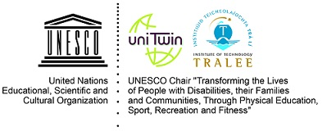

Contribution to OHCHR with respect to the Human Rights Council resolution 43/L.34 to support of the preparation of a study on sports following article 30 of the Convention on Rights of Persons with Disabilities.

This contribution was prepared by the UNESCO Chair “Transforming the lives of People with Disabilities their Families and Communities Through Physical Education, Sport Recreation and Fitness” connected with the global collaborative action we lead in relation to sport and human rights. Given the emphasis on girls and women in sport, this submission is endorsed by the International Working Group on Women and Sport (IWG), WomenSport International (WSI), International Association of Physical Education and Sport for Girls and Women (IAPESGW) and Women in Sport Foundation (WSF). Letters of endorsement are annexed below. In this documents sport is considered in the widest sense of the word and includes physical education, physical activity, recreation, leisure play, traditional sports and games and fitness.
We welcome the Human Rights Council resolution 43/L.34 as well as this opportunity from OHCHR to contribute to this thematic study. The UNESCO Chair was established by UNESCO in 2013 in the Institute of Technology Tralee Ireland. We work with UNESCO and other partners to advance disability inclusion in and through sport. The collaborative partners in this submission have worked with the UNESCO Chair in further addressing the double and intersectional discrimination experienced by women and girls with disabilities.
Our societies have not been built to be disability and gender inclusive. The resulting exclusion has been perpetuated by continuing to allow generations of graduates to emerge from the further and higher education institutions ill equipped to work with people with disabilities or to effectively include women and girls with disabilities. This impacts policy and practice.
We should no longer tolerate the retrofitting of disability inclusion and gender mainstreaming into the skills set of professionals working in physical education, physical activity and sport. Regulatory bodies that set standards for professionals working in areas that impact sport, physical education and physical activity need to mainstream disability and gender perspectives. There is a role for collaboration with ILO in this regard. Awareness of the role of all stakeholders, as duty bearers, with respect to human rights needs to be increased. Many are unwittingly perpetuating discrimination against women and girls with disabilities. Unequivocal guidance is needed for States, and onward to other duty bearers in sport, to appreciate their responsibilities. Accountability must follow, and human rights mechanisms call for such accountability. While the below quote relates to CEDAW, its sentiment can transfer to CRPD.
‘If those who sign agreements such as the Convention on the Elimination of Discrimination against Women, or who endorse the Beijing Platform for Action, do not translate commitments into actions, and are not held to account for these actions, these texts lose credibility. Accountability is essential if the world is to realise women’s rights and gender equality.’’ Ban Ki-Moon, Secretary-General of the United Nations 2007-2016

We propose the following specific actions, elaborated in the text that follows, to break structural discrimination against people with disabilities prioritising women and girls with disabilities:
- Publication of a fact sheet or special issue publication on sport and human rights prioritising disability and gender perspectives. Clarity on the role of duty bearers could be addressed- this needs to go beyond States to the other stakeholders who currently do not recognise themselves as having any role to play in protecting, respecting and fulfilling human rights as they relate to gender and disability mainstreaming in physical education, physical activity and sport.
- The HRC consider establishing a a) subsidiary expert mechanism or b) an open-ended intergovernmental working groups or c) special procedure on sport and human rights mainstreaming disability and gender perspectives to provide the Council with thematic expertise and forums, thus providing a platform for dialogue and cooperation. Alternatively, the HRC joins the Action being led by the UNESCO Chair in relation to human rights and sport as part of the Kazan Action Plan follow up actions.
- Call for more accountability from States and duty bearers therein through the UPR process with regard to their actions and inactions that are facilitators or barriers to the inclusion of people with disabilities in and through sport in a gender mainstreamed approach. The HRC could point to the tools and templates designed to improve the quality of reporting developed by the UNESCO Chair.
- Efforts to advance disability and gender mainstreaming in and through sport is central to CRPD article 30, but also has relevance across a range of treaty articles and goals of normative instruments. Relevant human rights instruments include CEDAW, CRC, ICESCR, UPR, while normative instruments include Sustainable Development Goals, Kazan Action Plan, the Global Action Plan on Physical Activity, UN Action Plan on Sport for Development and Peace. Addressing the multiple calls for disability and gender mainstreaming in and through sport would increase the justification for greater investment and attention on these areas, by creating a multiplier effect.
- There is currently no internationally comparable data on the engagement of people with disabilities in sport disaggregated by age, gender and impairment kind needed to report on article 30 and called for in article 31 of CRPD. Measures are underdevelopment at present that align with human rights indicators, incorporating those developed through Bridging the Gap by OHCHR (Kazan Action Plan follow up actions 1&2, GAPPA monitoring and surveillance framework, Worldwide Survey of PE). Reporting to CRPD, analysed by the UNESCO Chair found that current reporting is not focused on the specific articles and examples cited are not backed up by data. Again, calling for accountability through robust data is essential to evidence gender and disability mainstreaming in sport. Otherwise, we run the risk of getting a sample of nice examples of good practice that do not really inform the country level reporting, or that enable investment to go to where it is most needed by virtue of exclusion. Data on abuses in sport is needed and safeguarding measures are of critical importance given the heightened levels of abuse faced by those with disabilities in sport.
Only robust and accurate statistics can establish the vital benchmarks and baselines that translate our human rights commitments into targeted policies, and only they can measure how effective those policies truly are.
Navi Pillay, United Nations High Commissioner for Human Rights, May 27, 2013

Data gathered to report on CRPD – can be used to report to UPR, CRC, CEDAW, ICESCR, and a voluntary national review on the SDGS, and report on the Kazan Action Plan Commitments and the Global Action Plan on Physical Activity.

- Collaboratively building capacity. In collaboration with Council of Europe, the UNESCO Chair is leading the development of a human rights in sport toolkit and online learning programme. We welcome input from OHCHR and/or the HRC on this collaborative development which is in line with Kazan Action Plan. This will be ready in 2021 and will be made available to higher education institutions wishing to address Human Rights. In addition, the Chair has resources for higher education institutions and training organisations wishing to inclusivize or mainstream their programmes through a gender and disability lens. It is entitled, inclusive physical education, physical activity and sport (iPEPAS), see www.ipepas.com. We have also designed a programme for the global fitness industry to become more inclusive of people with disabilities developed by the UNESCO Chair with industry partners and field experts and it is available for global use www.justdoufit.com. It can also be embedded into higher education offerings to ensure fitness instructors emerge as inclusive practitioners.
- Alignment with regional human rights instruments. The UNESCO Chair conducted a mapping of UN treaty instruments with regional treaty instruments as they relate to people with disabilities in sport. Data gathered for regional human rights instruments may in many cases be relevant for UN reporting. This further maximises the value of investing in gathering such data. We have mapped instruments in the African Union, Asia, Organisation of American States and Oceania. The full report is available on request.

Context:
This document outlines some of the actions being undertaken by the UNESCO Chair and collaborative partners to support the implementation of Article 30 of CRPD and to break the structural discrimination against women and girls with disabilities.
Our Collaborators include: UNESCO, UNESCO Chair, UNDESA, UN Women, Commonwealth Secretariat, the Centre for Sports and Human Rights, the International Olympic Committee, the International Paralympic Committee, Special Olympics International, The International Committee of Sports for the Deaf (ICSD), Deaflympics, Disability in Sport International, Virtus- World Intellectual Disability Sport, Inclusion4Development, International Working Group On Women And Sport, Women’s Sport International, the Washington Group on Disability Statistics, IFAPA the International Federation of Adapted Physical Activity, FIEP the Fédération Internationale D´Éducation Physique, IHRSA the International Fitness Industry Association, ICSSPE the International Council of Sport Science and Physical Education, ICCE the International Council for Coaching Excellence, Global Active Cities, The Global Network on Disability Inclusive and Accessible Urban Development (DIAUD), Sport Matters (Pacific, Asia, Africa and Indigenous Australia), Sport Against Racism Ireland.
Kazan Action Plan Action 1 on Sport and Human Rights
The UNESCO Chair is leading a global consortium on Sport and Human Rights as part of our commitment and responsibility to the Kazan Action Plan (KAP) implementation. Details of the consortium are in the attached document.
KAP is structured around three main policy areas:
- Developing a comprehensive vision of inclusive access for all.
- Maximizing the contributions of sport to sustainable development and peace.
- Protecting the integrity of sport.
The UNESCO Chair has been charged by UNESCO with leading a coordinated response to intersectional inclusion in the three specific policy areas below:
I.7. Foster empowerment and inclusive participation
II.4. Build peaceful, inclusive and equitable societies
III.2. Protect children, youth and other vulnerable groups

Furthermore, as agreed with WomenSport International & the International Working Group on Women and Sport, we collaboratively address the double discrimination experienced by women with disabilities through actions on the following specific policy areas:
I.5. Enforce gender equality/Empower girls and women
II.6. Advance gender equality and empower all women and girls

The Human Rights instruments for which current reporting tools and templates (available here) have been developed under KAP Action 1 include:
The Convention on the Elimination of all Forms of Discrimination against Women (CEDAW),
The Convention on the Rights of Persons with Disabilities (CRPD),
The International Covenant on Economic Social and Cultural Rights (ICESCR) and
The Convention on the Rights of the Child (CRC),
Universal Periodic Review
VNR for the SDGs

CRPD, and related treaty articles, address sport well. However, there is a gap in how States, National Human Rights Institutions and the sport sector connects with, understands and facilitates the rights in and through sport outlined in CRPD. This is evident in reporting to the CRPD documented below. The current human rights based policy context and related momentum has drawn considerable attention to the agenda. The sports sector is now proactively mobilising itself to leverage human rights mechanisms to advance physical education, physical activity and sport especially as it relates to disability inclusion and gender equity.
KAP Action 1 on Sport and Human Rights Activities:
The KAP Action 1 process calls for treaty body support in this action believing this will bring symbiotic benefits. The ask to CRPD committee was:

- Consider publishing a General Comment on Physical Education, Physical Activity and Sport (PEPAS) (pertaining to Core Articles 30.5 and transversally through Articles 6, 7, 8, 9, 16, 19, 20, 24, 25, 26, 27, 31, 32 and 33).
- Advocate and endorse the development of a Human Rights Fact Sheet on Physical Education, Physical Activity and Sport.
- Ensure, through direct reference in guidance notes and/or list of issues, that state and non-state reporting mechanisms include representation from the PEPAS sector.
- Endorse and promote the development of reporting templates and advocacy tools on the CRPD and PEPAS.

Further thematic briefings were held in 2019 with CEDAW, CRC and held a side event at UPR. We held information briefings at the Convention on the Rights of Persons with Disabilities Conference of State Parties 11 & 12 in June 2018/ 2019 in New York, with UN Women, UIN DESA, International Paralympic Committee, Special Olympics International, Deaflympics, Ireland, Brazil, Monaco, San Marino, and Tunisia, joining the Action. Separately at COSP12 the Action was represented through a presentation at the Korean Peninsula event. Work is ongoing with the Organisation of American States to align this Action to their agenda on sport and human rights. In September 2019, the Action was also presented in Madagascar at the African Union First Regional Conference of African Ministers on the Implementation in Africa of the KAP. The emergent Antananarivo recommendations emphasise that national sports policies across Africa should “1.2. Ensure that inclusiveness and gender equality are mainstream components of national sports policies and recognize physical education, physical activity and sport as human rights for all”. In October 2019, a workshop was held for Pacific Island States on the Action, as well as representing it at the Sports Forum of the International Sports Federation for Persons with Intellectual Disability (INAS) (now Virtus: World Intellectual Impairment Sport) Global games in Brisbane also in October 2019.

A working paper presented to the Committee on the Rights of Persons with Disabilities accompanies this document and contains many references to good practices sought for in this consultation. A similar document presented to CEDAW is available on request.

CRPD: Analysis of LOIs, State Party Reports, Concerns/Observations and Recommendations.

The UNESCO Chair in preparation for our meeting with the CRPD committee conducted an analysis of communication to and from CPRD including:
a) State Parties Reports (n= 133)
b) List of Issues (n=84):
c) Concerns/Observations and Recommendations (n=23)

State Party Reports (OHCHR, 2019a) and List of Issues Documents were retrieved from the Office of the High Commissioner for Human Rights database (2019b), whereas observations and recommendations were retrieved from the Universal Human Rights Index (2019c). Results State Party Reports: 87% reported on sport, 22% on physical education and 16% on physical activity. Given the inferred as opposed to direct reference to physical education and physical activity this is not surprising, although the direct reference to these areas in a general recommendation may have a very positive impact on future reporting in these areas. The number of mentions was also significant (sport=2819, PE=90 and PA=29), although many sport mentions are direct references to the title of article 30.5, most relate to accessibility, legislative measures and promotion of sport for people with disabilities. Results LOIs: The CRPD has drawn attention to issues related to rights, education, health, children, service and care. For instance, health and education registered 423 and 473 counts respectively. Regarding physical education, physical activity and sport, sport was mentioned 34 times (not counting title related mentions of article 30.5) and there was no reference to physical education or physical activity. The issues of accessibility measures (26%), initiatives to promote access to sport (26%) and legislative actions (11%) were highlighted.
Results Observations & Recommendations: 10 observations and 13 recommendations around sport were made by the CRPD. Physical education and physical activity have never been mentioned. The revision of legislative and policy frameworks, accessibility to sport facilities and support to access the practice of sport were the most prominent topics.
State Parties report on physical education, physical activity and sport, but this process is neither systematic nor exhaustive. Some countries report on relevant topics around physical education, physical activity and sport, but they do not provide evidence or data to measure the impact of putting their legal framework into practice. The guidance given by CRPD on articles related to physical education, physical activity and sport was appropriate and had a cross-cutting intersectional approach, although limited in scale. Measures to increase physical accessibility to sport centres is a pertinent topic, however, there are many other factors that need to be addressed in order to promote participation of people with disabilities in sport.
There is significant scope for the CRPD to increase its guidance to State Parties regarding physical education, physical activity and sport to ensure realization of their rights. With the support of the physical education, physical activity and sport sector, the CRPD can leverage their capacity to call for greater attention to this agenda.
We also analysed reporting to and from CEDAW and this is available on request.

Disability and Gender
Three reports released in December 2018 point to the need to address disability inclusive development as a priority. CRPD covers all those with disabilities including women and girls. While CEDAW does not explicitly refer to girls and women with disabilities, General Recommendation No. 18 (a) notes that women with disabilities are doubly marginalized and recognizes the scarcity of data, and (b) calls on States parties to provide this information in their periodic reports and ensure the participation of women and girls with disabilities in all areas of social and cultural life.
Disability Inclusive Development in UNDP, released on December 3rd, 2018, in its work on human rights and access to justice, UNDP outlines its capacity to work with member states to support them in ‘meeting their obligations under the CRPD and other human rights treaties and support implementation of the UPR and treaty body recommendations towards disability inclusion’. UNDP also pledges support for supporting in gathering ‘evidence-based information on the types of barriers that exist for persons with disabilities in a national context recognizing the diversity of disabilities.’
The Empowerment of Women and Girls with Disabilities Towards Full and Effective Participation and Gender Equality, December 2018, references the CEDAW general recommendation mentioned above and multiple other normative references in supporting the principles of ‘no one left behind and nothing about us without us’. The goal of the strategy is to ‘contribute to UN Women’s efforts of achieving gender equality and empowerment of all women and girls with disabilities and ensure their full and effective participation in all aspects of life on an equal basis with others in the context of development, human rights, and peace and security.’ The approach is a three track multi-pronged approach;
Track I. Mainstreaming: Systematically include gender, age and disability perspectives across initiatives,
Track II. Targeted: The empowerment and meaningful and effective participation of all women and girls with disabilities as the main focus on initiatives,
Track III. Inclusion: Women with disabilities of all ages have a seat at the table, and agency.
This approach has been established by UN Women in the Guidance note – Gender Mainstreaming in Development Programming as one that ‘has greater potential for achieving gender equality and women’s empowerment ... This approach consists of combining gender-targeted or focused interventions for specific social groups, organizations and/or processes with gender efforts integrated across the substantive general work of all priority sectors.” We also recommend that is the disaggregated data by race, age, gender and disability be included.

Q&A
The questions laid out in the letter pertaining to the thematic study relate to countries, but we have added in perspectives from our networks.
Recreation and leisure
1(a). Does your country have laws, policies, plans, strategies or guidelines and departments at any level of government relating to the inclusion of persons with disabilities in mainstream (not disability-specific) recreational and leisure physical activity, including but not limited to:
- Private settings: Private gymnasiums, sports clubs, sports associations and foundations, summer camps, marathons, swimming pools, among others;
- Public and private tourism platforms: tourism facilities (e.g. beach, mountain, forest, among others), including services for persons with disabilities;
- Public settings in urban areas: Urban sports trails, cycling trails, public physical training, yoga, recreational sports, playgrounds for children, recreational facilities for older persons, among others.
- Nature trails: hiking trails, nature centres, toilets, viewing platforms, count with accessibility and services.

Practice varies across the globe in relation to accessibility laws, policies, plan, guidelines and related investment to make accessibility a reality. There are considerable gaps in our knowledge due to the lack of internationally comparable data. Measures are afoot to begin to gather such data. There are pockets of good practice, but accessibility is not mainstreamed globally. Current international normative instruments in sport advocate mainstreaming disability and gender equity and call for universal proportionality, investing where the need is greatest. The main instruments are the Kazan Action Plan (2017), the Global Action Plan on Physical Activity (2018), and the UN Action Plan on Sport for Development and Peace and related resolutions (2018; 2019). The implementation and follow up actions of these plans calls for some of the measures called for in this question.
The UNESCO Chair is leading on inclusive policy actions of Kazan Action Plan as referenced above. WomenSport International, International Association for Girls and Women in Sport, International Working Group and Women’s Sports Foundation have all indicated they are available to provide additional forums to promote action on policy..
1(b). What are the challenges to implementing the above? Are you aware of good practice related to the above?
Disability and gender mainstreaming are not part of the mindset of many professionals who create the environments/ settings above. We have lots of examples of good practice if needed but they are just that – examples, i.e. not systemic. A book on Disability Sport in Europe is under production that will address all these three areas of study. It will be ready in mid-2021.
Further to this, endorsing organizations are all positioned to add value by building awareness and promoting best practices.

Education
2(a). Does your country have laws, policies, plans, strategies or guidelines on physical education in public and private schools, including in special education, informal education and extra-curricular activities, relating to the inclusion of persons with disabilities, particularly children and young people, to avoid their exclusion or exemption from physical education and facilitating contact with disability-specific sports? What are the objectives of these instruments?
Laws, policies, plans strategies and guidelines may exist but there are is a policy – practice gap. More has changed at a policy level than is evident on the ground. The 3rd Worldwide study of Physical Education (2014) conducted by UNESCO available here evidences this. Section 6 of the report identifies that
The Physical Education World-wide Surveys I and II drew attention to varying practices across countries and regions in implementation of inclusion policies to secure gender and disability equality of provision. The Final Report of Worldwide Physical Education Survey II identified that whilst many countries have legislation in place, barriers to inclusion remained in both gender and disability areas. The Findings of the present World-wide Physical Education Survey provide evidence of increased consideration being given to equity issues with gains made but with some underlying issues and concerns remaining
The fourth Worldwide study launches this year. In the continued absence of pre-service vocational training in disability inclusion and universal design in education, the policy practice gap will remain, and teachers continue to report not feeling competent in including people with disabilities in their physical education classes.
2(b)(i). Are teachers and professors of physical education trained to include students with disabilities in either mainstream or disability-specific physical education?
The area of disability inclusion and universal design for learning remains a niche area in pre-service vocational training and in-service training internationally. The higher education sector is a duty bearer when it comes to respecting protecting and fulfilling human right obligations. They remain largely unaware of this responsibility. Those who set standards and or issue licences or certification for teachers, including teacher councils, could mandate covering gender and disability inclusion as part of pre-service training in line with human rights duties. Such training needs to engage learners with people with disabilities in order to effectively build competence. This could transform practice dramatically within a few years.
Human rights are a growth area in sport, identifying duty bearers and highlighting their responsibility is critical. Children are being denied their rights and the higher education sector is complicit by graduating professionals who lack the knowledge, competence and skill (and motivational and vocational attributes) to facilitate the realization of human rights of children with disabilities in their class (Please see attached publication for further detail).
2(b)(ii). Do persons with disabilities who want to be teachers and professors of physical education have access to equal certification to exercise the profession?
This is ad hoc at present and tends to be at the discretion of the host institution and awarding bodies and their willingness to accommodate. Again, clarity on duty bearer responsibility would help to address the structural discrimination. Currently available data on activity level of those with disabilities show a major gradient in participation, indicative of the barriers faced. This indicates that there is not equal access and thus it is less likely that persons with disabilities see the field as a valid one for them to consider. (People with disabilities are three times less active than the general population and 93% of women with disabilities are inactive at levels that promote health, and children with disabilities are 4.5 times less active than their peers without disabilities)
2(c). What are the challenges to implementing the above? Are you aware of any good practices related to the above?
The majority of people governing the sector did not cover disability and/or gender inclusion comprehensively in their vocational preparation. It is likely that they have no idea of how they are complicit in perpetuating discrimination through their action or inaction.
There are some examples of good practice – but we need to move beyond this. Many CRPD reports cite examples of good practice. We need a comprehensive vision of the overall situation backed up by good quality data, that is internationally comparable.
Sports

3(a). Does your country have national, regional and local sports departments addressing and promoting competitive sports that cover both mainstream and disability-specific sports, either integrated or separated?
3(b). Do disability-specific competitions have a similar structure to mainstream competitions, either integrated or separated, to organize local, regional, national, continental and international competition?
3(c). What are the challenges that persons with disabilities face to access training centers prepared for high-performance sports at local, regional and national levels?
3(d). Are there laws, policies and mechanisms in place to ensure fair distribution of public grants, awards and other financial support to ensure that sportspersons with disabilities have equal opportunities to succeed in competitive sports?
3(e). Please provide information on the organizational structures of disability-specific sports, including examples and good practices. Kindly consider the following aspects when replying:
- Are they separate structures, or are they integrated into mainstream federations and clubs?
- Are they decentralized covering the whole territory or they only operate in capital city/area?
- Are they sports-discipline specific, or they integrate multiple disciplines?
- Do they receive equal funding opportunities compared to mainstream sports?
- Are joint activities between sportspersons in disability-specific sports and mainstream sports encouraged or carried out to facilitate exchange among sportspersons within similar disciplines?
- Are persons with disabilities considered in sports beyond their role as sportspersons, including as referees, coaches, spectators, administrators, workers, volunteers in the sports industry, board members, among others?

Practice varies across the global with respect to the above. The questions above could be used in planning strategy or guidelines.

Annex 1 Letters of Endorsement

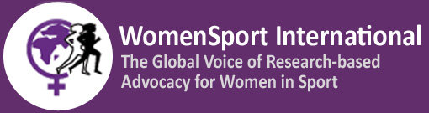
Date: July 28th, 2020
Re: Endorsement and support of the contribution to OHCHR with respect to Human rights Council Resolution 43/L.34 supporting the preparation of a study on sports following article 30 of the Rights of Persons with Disabilities from UNESCO’s Chair “Transforming the Lives of People with Disabilities, their Families and communities (ITLPDFC) through Physical Education, Sport, Recreation and Fitness.
This letter from WomenSport International (WSI) is to confirm WSI’s support and endorsement of the UNESCO Chair «Transforming the Lives of People with Disabilities», statements and suggestions to OHCHR with respect to the Human Rights Council Resolution 43/L.34 and in the preparation of a study on sports following article 30 of the Rights of Persons with Disabilities.
WomenSport International founded in 1993 is the global voice of research-based advocacy for Women and Girls in Sport. Through the research and educational activities of WSI’s members, WSI has become well recognized for its expertise and action on the status of and challenges impacting women and girls in sport. WSI specifically works to be inclusive and sensitive to the needs of girls and women with disabilities. Organizations such as the International Olympic Committee, (IOC), the International Council of Sport Science and Physical Education (ICSSPE) and the American College of Sport Medicine (ACSM) regularly engage the expertise of WSI members to present their research and recommendations for change.
Furthermore, WSI has consultative status to the United Nations Economic and Social Council and is a member of the Intergovernmental Committee for Physical Education and Sport (CIGEPS) consultative council. As a member of the consultative council WSI participated in the 2015 revision of the International Charter for Sport, Physical Activity, and Physical Education and the preparations and follow up of the MINEPS VI Kazan Report 2017.

Most recently, WSI contributed recommendations to the UNESCO Kazan Action Plan and the study on the Global Observatory on Women and Sport. Important to women around the world is WSI’s role in hosting presentations at the UN Commission on the Status of Women in partnership with the Women’s Sports Foundation US, the American College of Sport Medicine (ACSM) and the International Working Group on Women in Sports (IWG).
We believe strongly in the rights of all women and girls in sport to have equal opportunities to participate and grow within the sport sector and beyond. The statements and responses prepared by UNESCO Chair «Transforming the Lives of People with Disabilities” are a true representation of the challenges in bringing about a more equitable and inclusive environment.
As an organization, WSI is hopeful to be called upon to assist in the movement and policy actions to improve the status of rights for women and girls with a disability.

Diane Huffman, President – WomenSport International

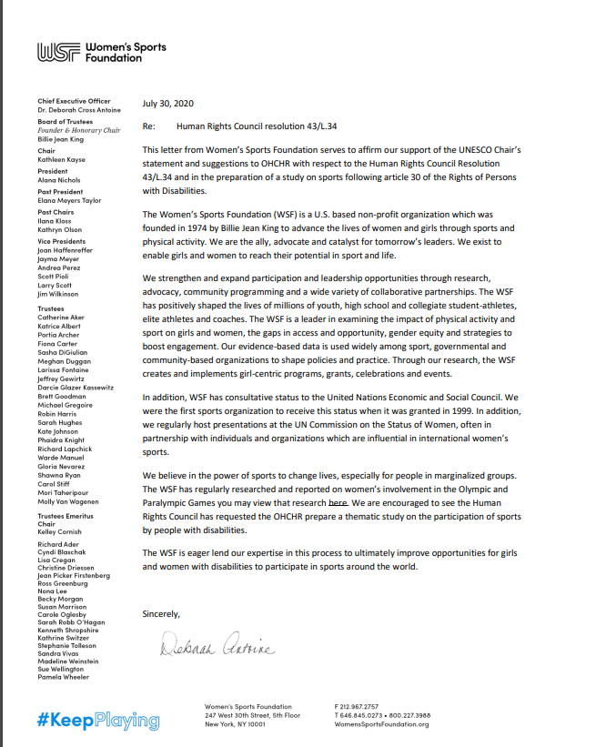

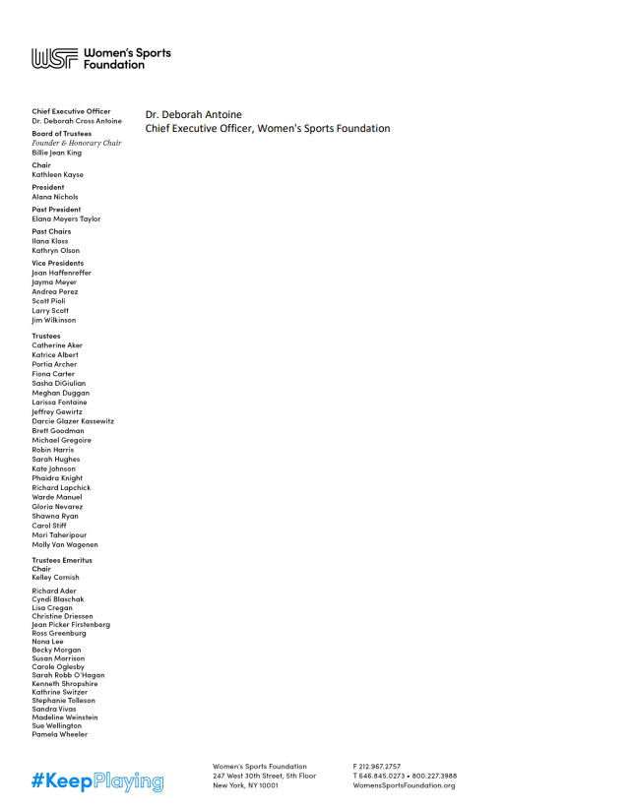

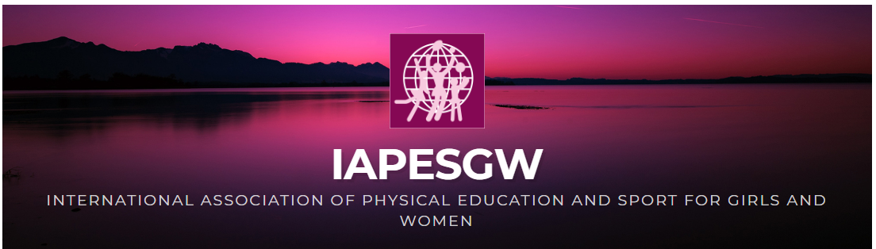

Confirmation of endorsement from IAPESGW- INTERNATIONAL ASSOCIATION OF PHYSICAL EDUCATION AND SPORT FOR GIRLS AND WOMEN

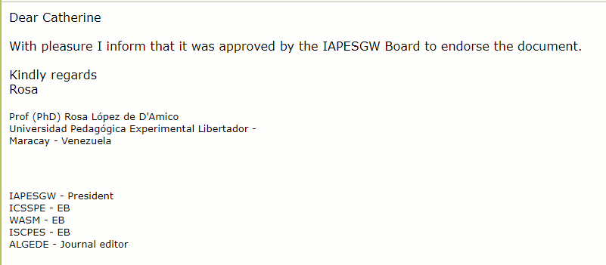

These regulations and guidelines should refer to ensuring accessibility of venues/facilities, accessibility of information and communications, reasonable accommodation, support service provision, affordability, procurement, data collection and disaggregation, among others.

