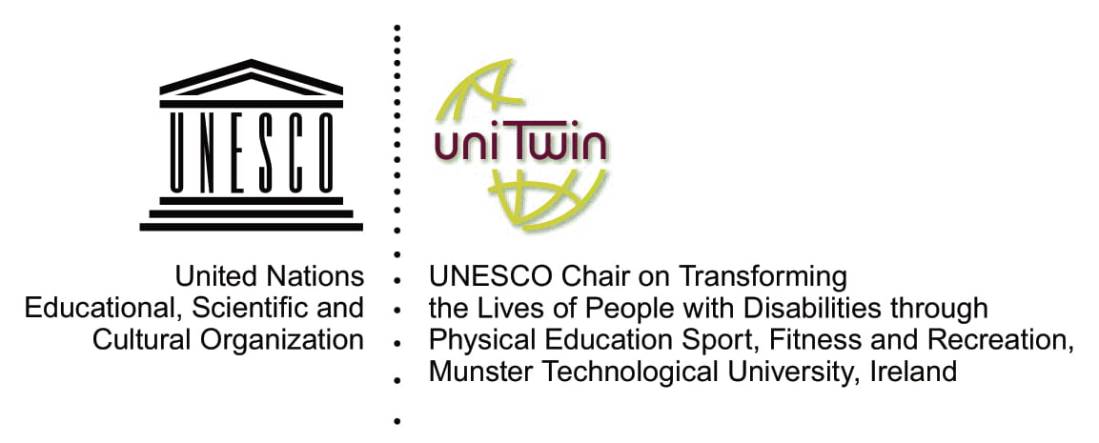
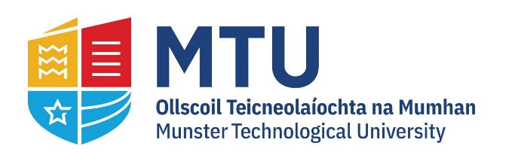

UNESCO Chair, Munster Technological University, submission to the request for input from the Department of Children, Equality, Disability, Integration and Youth on new and emerging issues in light of Ireland's national report to the Universal Periodic Review.

This contribution comes from the UNESCO Chair "Transforming the Lives of People with Disabilities their Families and Communities Through Physical Education, Sport Recreation and Fitness". UNESCO established the UNESCO Chair in 2013 in the Institute of Technology Tralee, which became Munster Technological University in January 2021. This submission responds to the request for inputs on new and emerging issues relevant to Ireland and the Universal Periodic Review (UPR) since Ireland's last report in 2016. It will mainly focus on developments pertinent to sport, human rights, and the Sustainable Development Goals (SDGs). The submission also offers some recommendations for consideration in the preparation of Ireland's report.

Emerging issues since 2016: The changing landscape of sport, human rights, and SDGs
As an overarching driving and unifying instrument, the 2030 Agenda has provided a focal point for the sport sector globally to unify and advance its alignment with sustainable development and human rights. In particular, paragraph 37 of the preamble states:

"Sport is also an important enabler of sustainable development. We recognise the growing contribution of sport to the realisation of development and peace in its promotion of tolerance and respect and the contributions it makes to the empowerment of women and of young people, individuals and communities as well as to health, education and social inclusion objectives."
(United Nations, 2015, p. 13, para.37).

Agenda 2030 is a rights-based plan. This enables the mapping of many SDG goals and targets to UN human rights treaties' articles. Therefore, action on the SDGs also contributes towards action on human rights in many cases.

Ireland adopted Agenda 2030 in 2015, before the second national report to the UPR; during this time, the sports sector initiated its response to the Agenda. In 2017, the sixth International Conference of Ministers and Senior Officials Responsible for Physical Education and Sport (MINEPS VI) adopted the Kazan Action Plan (KAP) "to facilitate international and multi‐stakeholder policy convergence, ease international cooperation and foster capacity‐building efforts of governmental authorities and sports". KAP is a coherent mechanism for policy development, implementation and monitoring aligned with universal human rights and the SDGs within and beyond the UN system.

Many other international policies link with this human rights agenda in and through sport. The 71st World Health Assembly in May 2018 endorsed the WHO Global Action Plan on Physical Activity 2018-2030. The United Nations General Assembly, at its 73rd session in 2018, adopted the resolution "Sport as an enabler of sustainable development". The resolution confirms the growing convergence around KAP in the alignment of work on sport across the United Nations system and Member States' recognition of its potential as a pivot point for policy coordination. It further acknowledges the significance and complementarity of the Global Action Plan on Physical Activity.
These actions are part of growing acknowledgement globally of the importance of human rights in and through sport. Human rights in and through sport refer to recognising sport as a human right and ensuring that sport at all levels protects human rights. Sport needs to protect children and make provisions against harassment and violence. Sport should also be used as a tool to promote other rights such as equality, non-discrimination, health and education. Actors from the sport sector, the human rights community and international organisations, are increasingly engaging with this agenda and with each other. Nonetheless, work is needed to increase understanding among sports stakeholders at national and grassroots levels.

TRUST Ireland: Action on this agenda in Ireland
With funding from the Democratic and Inclusive School Culture in Operation (DISCO) program of the EU and Council of Europe, the UNESCO Chair, and key partners, are developing TRUST – The Rights Understanding in Sport - as a training module for use in schools, colleges, clubs and the wider community, providing resources for teaching human rights in and through sport and for embracing a human rights approach to sport education. It includes theoretical and practical resources that will help foster effective rights-based sport education and delivery practices. TRUST also delivers advocacy and audio-visual materials to help raise awareness of the role that sport can play in promoting these rights, particularly when addressing the needs of all in sport, including minority groups.
In the Irish context, a partnership of the UNESCO Chair, the Federation of Irish Sport, Sport Against Racism Ireland, the Gaelic Athletic Association, the Central Statistics Office and Sport Ireland have launched TRUST Ireland- Sport as it should be. This project is funded by the Irish Human Rights and Equality Commission.
The project aims to:
- Increase understanding among state actors, the sports sector and grassroots organisations of sport both as a human right and as a tool for human rights promotion, including within the context of Irish reporting to UN human rights mechanisms.
- Ensure that grassroots organisations can articulate to the State their contribution towards implementing human rights through sport on the ground and hold the State to account regarding their human rights treaty obligations related to sport and facilitate conversations between all level of actors.
- Facilitate conditions for better engagement between all actors on human rights, sport reporting and policy development.
To achieve these aims, TRUST Ireland is preparing to host a series of workshops with rightsholders including; migrants, refugees and asylum seekers; travellers and ethnic minorities; members of the LGBTI+ community; women and girls; people with disabilities; and people from socio-economically disadvantaged groups. We will convene with the National Governing Bodies of Sport and Local Sports Partnerships, Higher Education Institutions and Education Training Boards. We will hold expert dialogues with representatives from across governmental departments. We hope that representatives from the Department of Children, Equality, Disability, Integration and Youth who work on the various inclusions remits and those with responsibility for UN human rights reporting will be able to attend this session. The sessions will allow each group and sector to focus on what aspects of human rights in and through sport are most applicable to them and work to progress this agenda. We will invite representatives from the other stakeholder groups to address each group to open engagement between stakeholders on this agenda. TRUST Ireland partners will train rightsholders from each of the identified groups to lead the rightsholder workshops to ensure that the sessions are as relevant as possible, fostering a sense of ownership over the process. We will create audio-visual materials and a guide for states on implementing human rights and sport commitments. We hope that national human rights institutions and interested organisations in other countries will adopt TRUST Ireland as a good practice model for socialising human rights in and through sport and engendering multi-stakeholder cooperation in this domain.

State guide to reporting on sport to the UPR
Following the Kazan Action Plan's adoption in 2017, the UNESCO Chair was charged with leading a global consortium to advance the inclusive policy actions of the Kazan Action Plan and its five follow-up actions. This action (action 1) focuses on respecting, protecting and fulfilling human rights in and through sport. The action closely aligns with a separate action (action 2) on measuring the contribution of sport, physical education and physical activity to the SDGs. Under action 1, the UNESCO Chair, in collaboration with many international partners, has developed a series of draft tools for states, NHRIs and civil society to assist them in reporting to the UN human rights monitoring bodies on human rights in and through sport. These draft tools include reporting indicators that are largely aligned to indicators being developed under action 2 of the Kazan Action Plan and human rights indicators developed by OHCHR. The tools will be updated to reflect the final output of action 2. You can find the tools for State reporting to the UPR here.

Inclusive and intersectional reporting
The collection and use of robust, high-quality data are essential for making evidence-based decisions regarding policy development, implementation, funding, monitoring, and evaluation. Data collection, disaggregation and associated representation can affect how different groups are considered in policy and reporting. Accurately portraying the situation regarding human rights in a country requires particular attention be given to traditionally marginalised groups. Therefore, data included in human rights reporting should be disaggregated to ensure information reflects the state's plurality of experiences. An intersectional approach, which recognises that people are more than a single identity and many people will fall into two or more groups that may face discrimination resulting in a unique or compounding experience, has gained traction in recent years. Adopting intersectionality awareness when preparing reports will result in a more accurate and inclusive overview of the human rights situation.
Recommendations for Ireland's national report to the UPR
- The UNESCO Chair acknowledges that the UPR is specific to human rights monitoring. However, the rights-based nature of Agenda 2030 and the significant overlap between the SDGs and human rights articles means that action on the SDGs is often also action on human rights. Therefore, the UNESCO Chair recommends that the Department consult with the Department of the Environment, Climate and Communications, and the Central Statistics Office to finalise the report to the UPR for input on data and information gathered concerning the SDGs, which may also be relevant to human rights.
- Consider the submission from Coalition 2030 about alignment with the SDG Agenda.
- The intervening period between Ireland's second and third reports to the UPR has seen significant international convergence around action for human rights in and through sport, which acknowledges sport as a human right, the need to protect human rights in sport and the role of sport in promoting human rights. We recommend that the Department reflect the linkages between sport and human rights in their national report and highlight any relevant data, policies and programmes in this regard.
- The OHCHR acknowledges that the UPR is an opportunity to share the best human rights practices around the globe. We suggest that Ireland's report could share the TRUST Ireland model as an example of good practice in human rights capacity building.
- The UNESCO Chair, has developed tools on reporting to the UN human rights monitoring mechanism on human rights in and through sport. We recommend that the Department consult the draft tool on state reporting on sport to the UPR, disseminate the tools to relevant stakeholders and report on these tools in the state report (available here).
- Disaggregated data and intersectional awareness can significantly improve the quality and relevance of information. We recommend that Ireland's UPR report use disaggregated data where available and include international perspectives.
For further information, please email: Catherine.carty@ittralee.ie and sarah.carney@staff.ittralee.ie or phone Catherine on 087 2868250.

Throughout this note the term ‘sport’ is taken as a broad construct that encompasses the areas of physical education, physical activity and sport as is typical in UN dialogues and publications on ‘sport’ (UNESCO, 2017; United Nations General Assembly, 2004).

